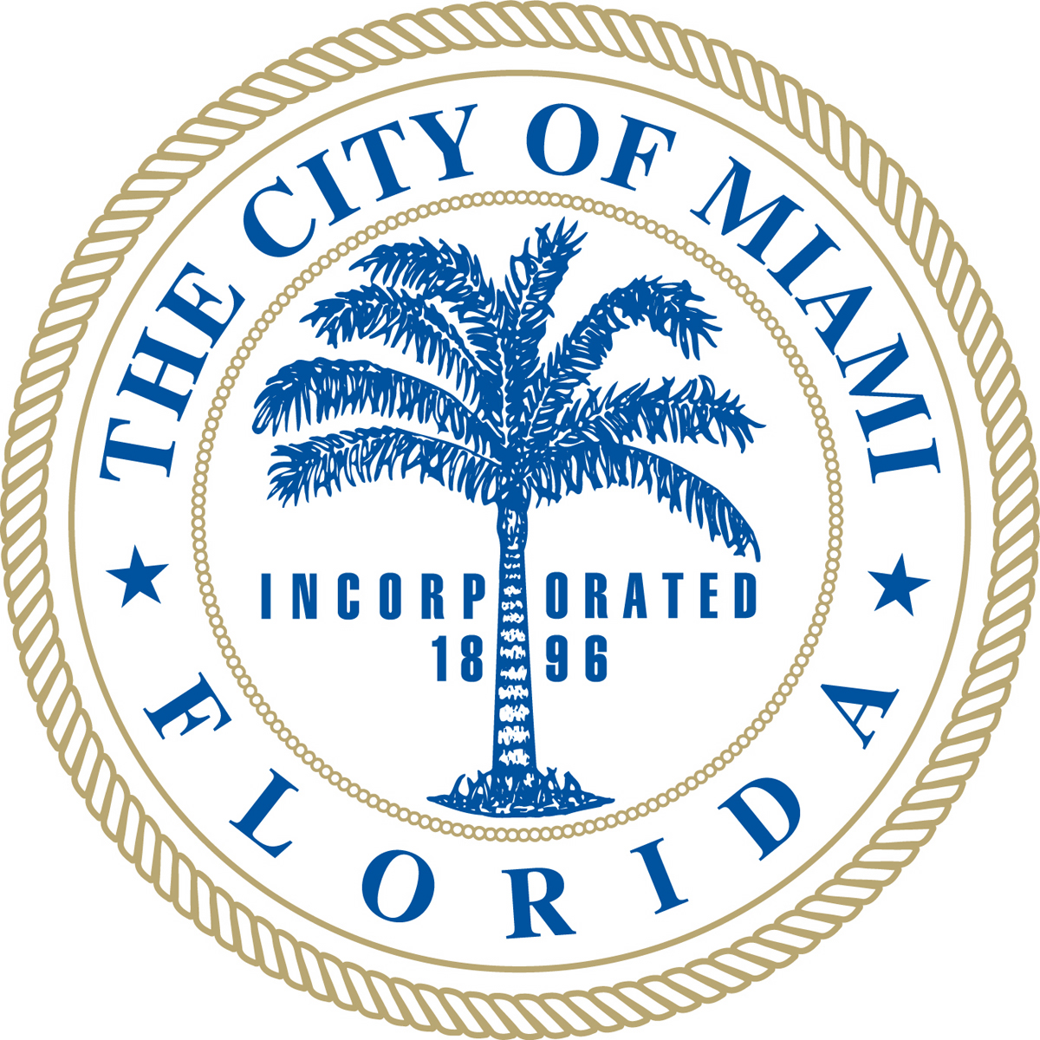
Mayor Tomás Regalado

MBF SmALL BUSINESS Training Application
CRITERIA
- Minority Owned (Minimum 51% Minority Owned);
- Domiciled in the City of Miami (as stated on occupational license);
- Business must be in existence for more than six months;
- US Citizens or Lawful Permanent Residents only;
- No sole proprietorships.

DIRECTIONS
1. Print application (2 pages) and fill it out entirely.
2. Enclose financial statements for the last two years (Balance Sheet and Profit & Loss statement). If you are a new business, enclose financial statements for the last six months.

There are several ways to submit your completed application form:

By Email:
Scan the documents and attach to an email to Cara@MiamiBaysideFoundation.org

By Mail or By Hand:
Attn: Cara Sadira
Miami Bayside Foundation
25 SE 2nd Avenue, Suite 240
Miami, FL 33131

This Application is an initial assessment designed to help us understand you, your business, and why you are interested in the program. This information will be kept confidential. If selected for an interview, please note that you will be asked to complete an Interview Addendum and submit supporting documentation.

Applicant Information
Last Name: |  | First Name:
Social Security#: |  | Email:
Work Phone: |  | Cell Phone:
Gender: (please mark with x)  ___ Female ___ Male |  | Check all that apply: (please mark with x)  ___ American Indian or Alaska Native  ___ Asian American  ___ Black or African American  ___ Hispanic or Latino  ___ Native Hawaiian or Other Pacific Islander  ___ Woman  ___ Disabled  ___ Veteran
COMPANY INFORMATION
Company Name: |  | Applicant Title:
Company Address:
City: | State: |  | ZIP Code:
Year Business Was Founded: | Year You Acquired Ownership: |  | Percentage of Business You Own:
EIN: |  | DUNS #:
Employee Count (please enter number)  Fulltime:  Part-time:  Temporary/Contractors: |  | Annual Gross Revenue  2015:  2016:  2017 (to date):  2017 (projected full year):

Further questions
- How did you hear about MBF’s Small Business Training? (please mark with x all that apply)

___ Commissioner Office (please indicate name of Commissioner): ____________________________
___ Miami Bayside Foundation Website
___ Financial Institution (please specify): ________________________________________________
___ Social Media (please specify): ______________________________________________________
___ Other (please indicate organization or individual): ______________________________________

- Please briefly describe the products or services your business offers:

- Briefly discuss why you are interested in MBF’s Small Business Training and what you expect to get out of it. How will it enable you to grow your business?

I confirm that the above information is accurate.

I hereby authorize Miami Bayside Foundation (MBF) and the other entities conducting the Small Business Training initiative to verify information presented here and to check personal and business references. I grant permission of my likeness or image to be used for informational and promotional purposes related to my participation in MBF’s Small Business Training program if selected as a participant.

I understand that information produced from this verification and reference check may contain information about my background, character, credit history, personal reputation and past and current compliance with laws and regulations in the US. I also voluntarily authorize MBF to perform checks of my previous employment/business ownership history. I hereby release all persons or entities and program facilitator from liability arising from requesting or supplying such information.

Print Full Name __________________________________________ Date: __________________

Signature ________________________________________________

