Dear MBF Community,

Florida has announced its Florida Small Business Emergency Bridge Loan Program (FSBEBL) in response to coronavirus business interruption. The bridge loans are up to $50,000 with NO interest for one (1) year. Details on the program are below. Please note that loans made under this program are not grants.
FSBEBL details:
- Qualified Applicant: Must be a Florida for-profit established prior to March 9, 2020 with 2 to 100 employees (1099 Employees count).
  - At least 51%, individually or collectively, of the equity of the business must be represented in the filing.
- Amount: Up to $50,000 per eligible small business. Loans of up to $100,000 may be made in special cases as warranted by the need of the eligible small business.
- Term: 1 year.
- Limitation: Only one loan may be made per eligible business. All previous bridge loans received MUST be paid in full.
- Interest Rate: Loans will be interest-free for the loan term (1 year). The interest rate will be 12% per annum on the unpaid balance thereafter, until the loan balance is repaid in full.
- Application Period: Applications will be accepted by qualified Florida small businesses under this program through May 8, 2020, contingent on the availability of funds.

To apply, gather the following:
- Government issued personal identification of all individual applicants (driver’s license, state or federal ID, or passport).
- Federal Business tax returns for the last 2 completed years, if available.
- Employer tax documentation.
- Personal tax returns for the last 2 completed years with attached Schedule C for all individual applicants, if available and where appropriate.
- Additional information that the applicant believes would assist the Loan Review Committee in making its decision (such as one-page overview of business, interim P&L for 2020, loan summary, and a letter of explanation for any credit or repayment issues).
- Please Note: Credit Report of each owner on the application will be pulled by Florida First Capital Finance Corp. after application is submitted.

Useful links:
- Frequently Asked Questions (pdf)
- Eligibility Requirements (pdf)
- Checklist for Necessary Documents (pdf)

Once you have your documents ready, then go to website and follow instructions for applying online.
- Website for applying http://floridajobs.org/rebuildflorida/businessrecovery
- Attached is a information sheet on how to fill out the online application

As always, if you have any questions, please call or email.

Be Safe,
The MBF Team

The Florida Small Business Emergency Bridge Loan COVID-19
Application Step-By-Step Process

- Go to https://deosera.force.com/RebuildFloridaBusinessLoanFund/s/
- If you already have an account, login. If not, sign up.
  - If you are signing up for the first time, please make sure to verify and confirm your email to continue with the application process.
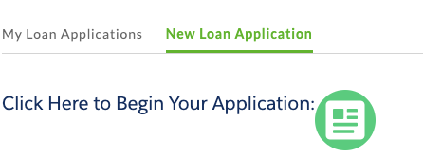
- Click on the “New Loan Application” tab.

Note: Even if you have previous applications or already had an account, you still have to start a new loan application.

- Then click on the icon to begin your application.
- Answer eligibility questions.
- Fill out each of the application sections. The applicant will need to click “Click to Edit Section” next to the section they would like to complete.
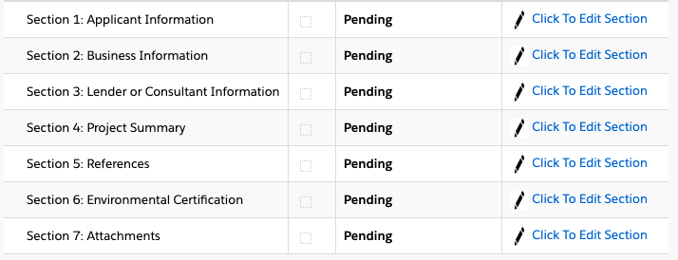

Note: For the Small Business Emergency Bridge Loan, Sections 1, 2, 3 and 7 should be completed in full. Only enter the requested loan amount should be entered into the table in Section 4. Sections 5 and 6 are auto filled. Once all questions have been answered, the applicant will need to click “Save” for each Section!

  - Section 1: Application Information
    - Fill in general information about the applicant, provide a brief description of how the business was impacted, provide the date of the application, and the applicant must read the disclaimer and certify all the statements.
  - Section 2: Business Information
    - Business name, type of business, RA#, if business has ever been turned down by a loan, owner(s) information, etc.
  - Section 3: Lender or Consultant Information
    - If the applicant is working with a third-party lender or an SBDC consultant to complete the application, then complete appropriate sections.
    - If NOT, the applicant must check the box “I am completing this application independently (without lender or consultant).

  - Section 4: Project Summary
    - The requested loan amount is the only information that needs to be entered into the table in Section 4.
Under “Source of Funding – DEO” and “Working Capital”

  - Section 5: References and Section 6: Environmental Certification
    - Ignore these sections! Once the required sections are completed (sections 1-3, loan amount in section 4, and section 7), then these sections will auto filled.
  - Section 7: Attachments
Note: Each attachment should be renamed according to the following guidelines to ensure quick response time.
    - Business Tax Returns: named as business tax return year XXXX
    - Employer Tax Documentation: employer tax document
    - Individual Tax Returns: individual tax return year XXXX
    - See website for additional documentation.

Note: Applicant may voluntarily provide additional information that will add context and assist the loan committee in making an informed loan decision. Additional information may include:
- Overview of business.
- Interim financial statements (profit & loss) for the current year-to-date: name as interim financial statement
- Additional filing requirements providing monthly sales figures: sales figures
- Explanation of credit report concerns and issues: credit report issues

- Double check that all information is correct and submit your application.

For more information on filling out the application, click here to access the DEO’s presentation.

For questions, contact FloridaBusinessLoanFund@deo.myfloirda.com or call 1-833-832-4494.

